1.Write a C program to simulate a Deterministic Finite Automata (DFA) for the given language representing strings that start with a and end with a
CODE:
#include <stdio.h>
#include <string.h>
int main() {
char str[100];
int n;
printf("Enter a string: ");
scanf("%s", str);
n = strlen(str);
if (str[0] == 'a' && str[n - 1] == 'a')
printf("String Accepted\n");
else
printf("String Rejected\n");
return 0;
}
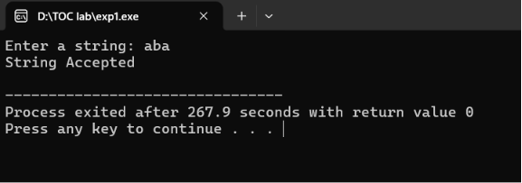
OUTPUT:

2.Write a C program to simulate a Deterministic Finite Automata (DFA) for the given
language representing strings that start with 0 and end with 1
CODE:
#include <stdio.h>
#include <string.h>

int main()
{
char str[100];
int n;
printf("Enter a binary string: ");
scanf("%s", str);
n = strlen(str);
if (str[0] == '0' && str[n - 1] == '1')
printf("String Accepted\n");
else
printf("String Rejected\n");
return 0;
}
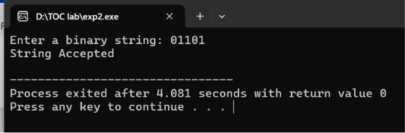
OUTPUT:

3. Write a C program to check whether a given string belongs to the language defined
by a Context Free Grammar (CFG)
S → 0A1 A → 0A | 1A | ε
CODE:
#include <stdio.h>
#include <string.h>
int main()
{
char str[100];
int n, i, valid = 1;
printf("Enter the string: ");
scanf("%s", str);
n = strlen(str);
// Minimum length is 2 (01)
if (n < 2)
{
printf("String Rejected\n");
return 0;
}
// Check whether all characters are 0 or 1
for (i = 0; i < n; i++)
{
if (str[i] != '0' && str[i] != '1')
{
valid = 0;
break;
}
}

if (valid && str[0] == '0' && str[n - 1] == '1')
printf("String Accepted\n");
else
printf("String Rejected\n");

return 0;
}
OUTPUT:

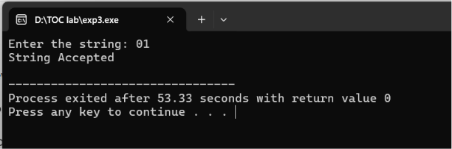
4. Write a C program to check whether a given string belongs to the language defined
by a Context Free Grammar (CFG)
S → 0S0 | 1S1 | 0 | 1 | ε
CODE:
#include <stdio.h>
#include <string.h>
int main()
{
char str[100];
int i, n, flag = 1;
printf("Enter a binary string: ");
scanf("%s", str);
n = strlen(str);
// Check whether the string contains only 0 and 1
for(i = 0; i < n; i++)
{
if(str[i] != '0' && str[i] != '1')
{
printf("String Rejected\n");
return 0;
}
}
// Check palindrome
for(i = 0; i < n / 2; i++)
{
if(str[i] != str[n - i - 1])
{
flag = 0;
break;
}
}
if(flag)
printf("String Accepted\n");
else
printf("String Rejected\n");

return 0;
}
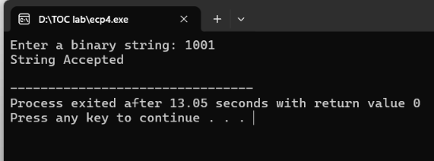
OUTPUT:

5. Write a C program to check whether a given string belongs to the language defined
by a Context Free Grammar (CFG)
S → 0S0 | A A → 1A | ε
CODE:
#include <stdio.h>
#include <string.h>

int main()
{
char str[100];
int i = 0, j, n;
int left0 = 0, right0 = 0;
printf("Enter the string: ");
scanf("%s", str);
n = strlen(str);
j = n - 1;
// Count leading 0's
while (i < n && str[i] == '0')
{
left0++;
i++;
}
// Count trailing 0's
while (j >= 0 && str[j] == '0')
{
right0++;
j--;
}
// Number of leading and trailing 0's must be equal
if (left0 != right0)
{
printf("String Rejected\n");
return 0;
}
// Middle part should contain only 1's
for (i = left0; i <= j; i++)
{
if (str[i] != '1')
{
printf("String Rejected\n");
return 0;
}
}
printf("String Accepted\n");
return 0;
}
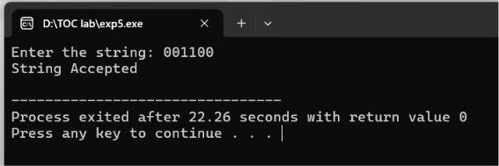
OUTPUT:

6. Write a C program to check whether a given string belongs to the language defined
by a Context Free Grammar (CFG)
S → 0S1 | ε
CODE:
#include <stdio.h>
#include <string.h>
int main()
{
char str[100];
int i = 0, zeros = 0, ones = 0, n;
printf("Enter a binary string: ");
scanf("%s", str);
n = strlen(str);
// Count leading 0's
while (i < n && str[i] == '0')
{
zeros++;
i++;
}
// Count following 1's
while (i < n && str[i] == '1')
{
ones++;
i++;
}
// If extra characters remain or counts are unequal
if (i != n || zeros != ones)
printf("String Rejected\n");
else
printf("String Accepted\n");
return 0;
}
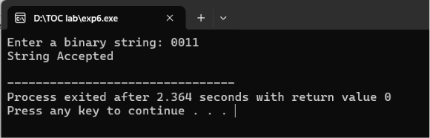
OUTPUT:

7. Write a C program to check whether a given string belongs to the language defined
by a Context Free Grammar (CFG)
S → A101A, A → 0A | 1A | ε
CODE:
#include <stdio.h>
#include <string.h>
int main()
{
char str[100];
printf("Enter a binary string: ");
scanf("%s", str);
if (strstr(str, "101") != NULL)
printf("String Accepted\n");
else
printf("String Rejected\n");
return 0;
}
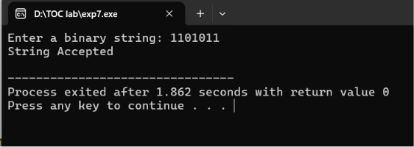
OUTPUT:

8. Write a C program to simulate a Non-Deterministic Finite Automata (NFA) for the
given language representing strings that start with b and end with a
CODE:
#include <stdio.h>
#include <string.h>

int main() {
char str[100];
int len;
printf("Enter the string: ");
scanf("%s", str);
len = strlen(str);
if (len > 0 && str[0] == 'b' && str[len - 1] == 'a')
printf("String Accepted\n");
else
printf("String Rejected\n");
return 0;
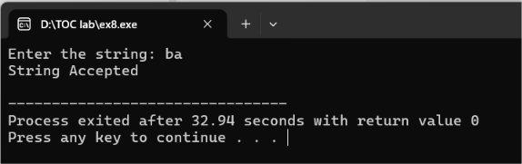
}

9. Write a C program to simulate a Non-Deterministic Finite Automata (NFA) for the
given languagerepresenting strings that start with o and end with 1
CODE:
#include <stdio.h>
#include <string.h>
int main() {
char str[100];
int len;
printf("Enter the binary string: ");
scanf("%s", str);
len = strlen(str);
if (len > 0 && str[0] == '0' && str[len - 1] == '1')
printf("String Accepted\n");
else
printf("String Rejected\n");
return 0;
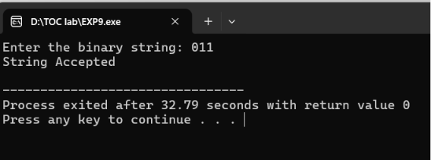
}

10. Write a C program to find ε -closure for all the states in a Non-Deterministic Finite
Automata (NFA) with ε -moves.
CODE:
#include <stdio.h>
int n;
int e[10][10];
int visited[10];
void epsilonClosure(int state)
{
int i;
visited[state] = 1;
printf("q%d ", state);
for(i = 0; i < n; i++)
{
if(e[state][i] && !visited[i])
epsilonClosure(i);
}
}
int main()
{
int i, j;
printf("Enter number of states: ");
scanf("%d", &n);
printf("Enter epsilon transition matrix (0/1):\n");
for(i = 0; i < n; i++)
for(j = 0; j < n; j++)
scanf("%d", &e[i][j]);
for(i = 0; i < n; i++)
{
for(j = 0; j < n; j++)
visited[j] = 0;
printf("ε-Closure(q%d) = { ", i);
epsilonClosure(i);
printf("}\n");
}
return 0;



